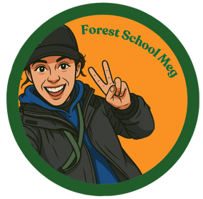

Forest School Meg Holiday Club FAQ’s
Contact Details: Meg – 07955397910, forestschoolmeg@gmail.com
What are the timings?
Holiday Club runs from 9:00am – 4:30pm. Please arrive promptly for drop-off and collection.
The Forest School area is a short walk from the car park so please aim to arrive @ Heron Farm for 8:45 so we can start promptly at 9am.
What if I’m late?
Things happen, we get that. Send Meg a text or give her a call – leave a message if she can’t answer.
We’ll hold on at our Forest School base for around 20/30 minutes before we get moving, after that we can arrange to meet you where we are.
Do you run in bad weather?
Yes, most sessions go ahead outdoors in typical British weather. Only extreme conditions will result in cancellation (see cancellation policy).
What are your ratios?
We maintain safe adult-to-child ratios in line with the Forest School Association & Ofsted guidance.
Usually 1:10, but sometimes we may have guest adults attending, volunteers, or extra leaders allowing us to increase our numbers.
What should my child wear?
Children should come dressed for the outdoors in all weather, it might be a mix of all of the following:
During the winter:-
Waterproof coat and trousers/puddlesuit
Sturdy shoes or wellies
Warm layers
-Spare socks & shoes

During the summer:-
Shorts & T-shirts
Sun hat and sunscreen
What should my child bring?
Packed lunch
Water bottle
Spare clothes (if appropriate)

What will my child be doing?
Holiday clubs are child led, so activities can vary. Activities may include:
Den building
Nature Crafts
Games
Exploration & free play
Fire Lighting
Tools
We focus on fun, confidence, resilience, creativity and connection.

What if my child is nervous?
That’s completely normal, a new place with a new adult and new children can feel daunting. We have lots of experience dealing with this. We create a welcoming, gentle environment where children can take their time and join in at their own pace. We do recommend that parent’s do not stay where possible, but we’ll work together on the day to decide what’s best for everyone.
We also try to encourage to leave toys from home at home. However, we understand sometimes a comfort from home helps, although we will try and encourage all precious things from home to be kept in our bags so they don’t get lost damaged or broken.

